**ReelWorx – Sprint 3**

Design Fixes

* Fix colors scheme on sign-in (can’t see create account)

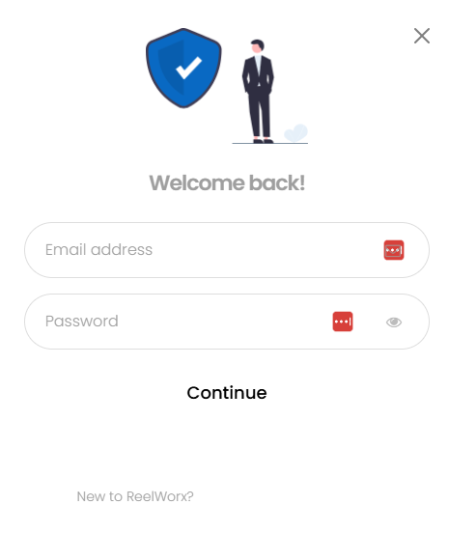

* Update search bar and sign-in colors



Sign-up

* New Candidate Account is automatically a candidate and affiliate role (no need for affiliate registration)
* Change all existing to candidates to affiliates as well

Job Details Page (example - https://reelworx.jobs/jobs/poet/)

* Design Changed
  + Play video when page loads
  + Move Like/Refer/Apply to top of page in banner with job title (right side)

* If the user clicks Like/Refer/Apply
  + Check for sign-in
    - If not signed in then send to sign-in/create account popup and return to job detail page after sign-in
    - If signed-in
      * Apply button goes to external URL, capture affiliate info
      * Refer and Get Rewarded goes to Share Link Popup
* Share Link Popup
  + Add “Participation in this referral program is open to the public; however, financial compensation will only be provided to individuals who are currently employed by the organization associated with the job posting, and we disclaim any liability for misrepresentation of employment status.”
  + User must check box to agree to term before copy link button or social media icons are able to click
    - Would be good if these were all greyed or overlay until checkbox clicked

* Add Additional Media section
  + Below the video where refer/apply used to be
  + Example podcast link - <https://notebooklm.google.com/notebook/d00bf756-b10d-4431-bd2b-8cab9a6f2241/audio>
  + Also add Additional Media URL to the Create new job page so it populates here. Put the new field under the Job Reels URL field

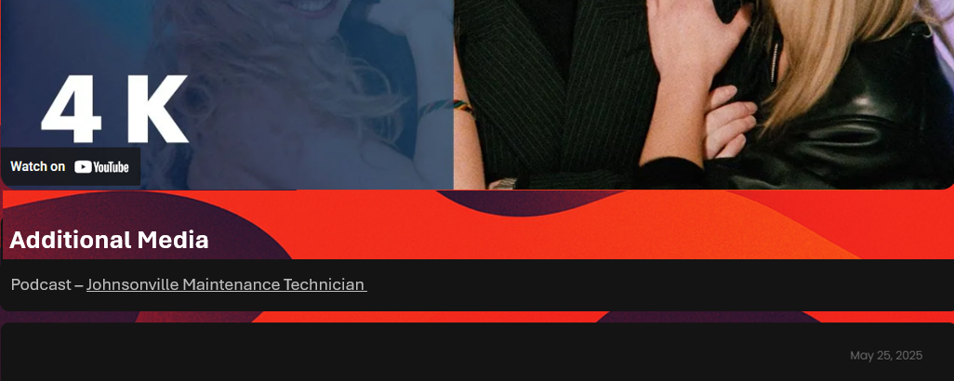

Candidate Profile

* <https://reelworx.jobs/candidate-dashboard-profile/>
  + All fields - Leave as is for now
  + What are required fields?
    - Maybe none if going to external ATS model
  + Admin Tools
    - Rename Affiliate Area

Backend User Role for managing

* Company
* Job
* Candidates
* Affiliates

Email notifications

* Please verify that email notification are still working . . .may have been an issue after last wp smtp plugin update