ReelWorx Design Update

On the Job List page (https://hughowbh.elementor.cloud/jobs-list/)
- When clicking on the video thumbnail, send to the job details page instead of directly to the youtube video

On the Company & Candidate Edit Profile Page
Company example - (https://hughowbh.elementor.cloud/company-dashboard-profile/)
Candidate example – (https://hughowbh.elementor.cloud/candidate-dashboard-profile/)
- Company Edit Profile Page Only - Remove options for cover typer and cover image
- Company Edit Profile Page Only - Keep Upload Logo – add “Recommended Size 600x600” next to upload logo
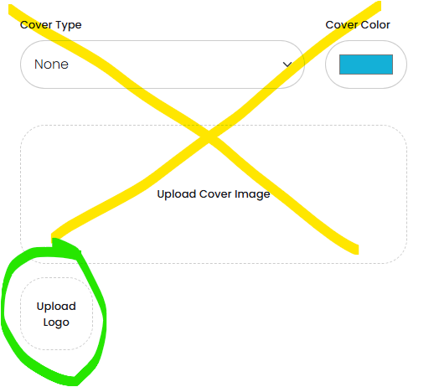
- Both - Change Twitter to X
- Both - In the Video Section, Remove Title field (don’t think being used) and change the YouTube Video ID to be the full youtube URL. Title the Field “YouTube Video URL”. Leave the example but un-bold the ID in the example
- Both - Also move this Video section to be just above Location section
On the Company Profile page (ex. https://hughowbh.elementor.cloud/companies/brad-company6/)
- Place the logo and company name above the video
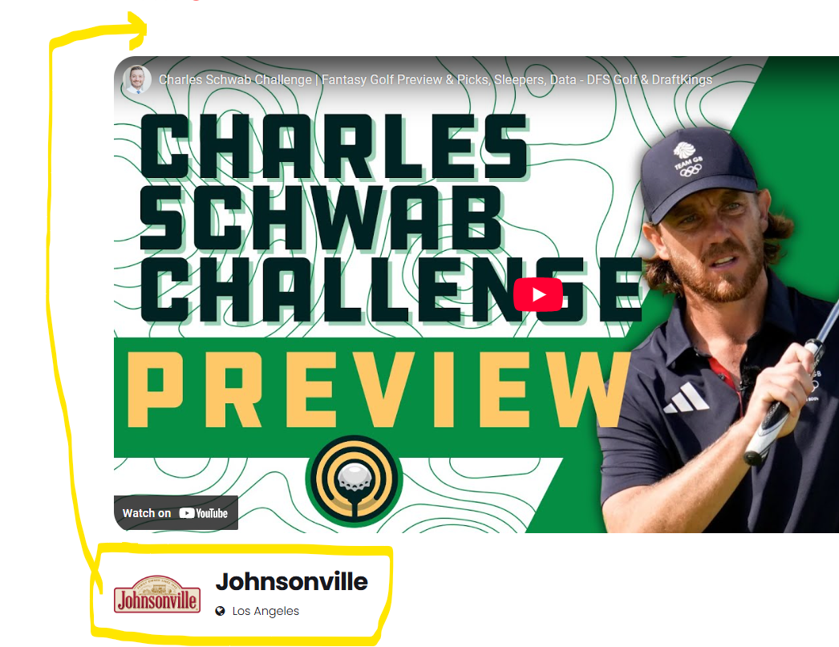

On the Candidate Profile page (ex. https://hughowbh.elementor.cloud/candidates/brad-jones/)
- Move video to be just below the photo or cover image if it exists

On the New Job Offer Page (https://hughowbh.elementor.cloud/company-dashboard-new-job/)
- Remove the Apply job external URL field
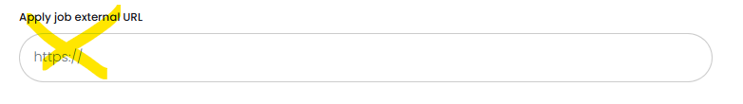
- Rename the Additional Info Section to “Video” and rename the Video Field to “Job Reel Video URL” and then add the same example from the company profile page
- Also Move the Video Section to just above the Location section

